REPAIR OF ROAD EMBANKMENT FAILURE USING
REINFORCED SOIL WALL

Chin Tat Hing
Perunding Menara Sdn. Bhd.

Jason Khor Lee Chong, Tan Cheng Chong, Nehemiah Lee Chee Hai
Nehemiah Reinforced Soil Sdn. Bhd.

ABSTRACT

An old road embankment slip failure occurred at KM 25.5, Kota Kinabalu – Tambunan road during the peak of monsoon seasons in November 1998. A site investigation was carried out to determine the subsoil condition and the possible causes of failure. The likely cause of failure is due to the saturation of interparticular pores of the residual soil as a result of the infiltration of the rain water. Four proposals were put forward for the remedial work. Finally, Nehemiah wall was selected as the remedial solution due to its cost effectiveness, speed of construction, practicality and durability. This paper summarises the subsoil condition, causes of the embankment failure, four remedial proposals and describes the design and construction of the rectification work using Nehemiah wall.

1.0 INTRODUCTION

Kota Kinabalu – Tambunan road is major trunk road of 80 Km long connecting the west coast to the interior areas of Sabah (Fig 1). It begins from Kota Kinabalu traverses eastwardly toward the Crocker Range. The road ascends slowly to 2000 meters above the mean sea level in mid way and then continues to descend to Tambunan town.

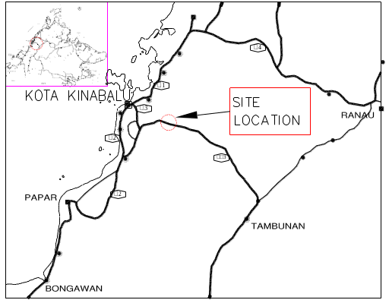 FIGURE 1 : LOCALITY MAP
In November 1998, the monsoon season brought unusual heavy rain to the east coast of Sabah. The continuous rain had caused flooding to some areas of the state. Kota Kinabalu – Tambunan road was also affected. A massive road embankment failure had occurred at Km 25.5 which caused the entire road to be cut off from the entire road network. A typical section of failed embankment is shown in Fig. 2. No vehicle could pass through this section of the road. As a consequence, an emergency work was called in by the Government to carry out the immediate repair to the road.

In this paper, the processes of investigation and design work are described. Finally, a remedial work is proposed for the rectification work of the road.
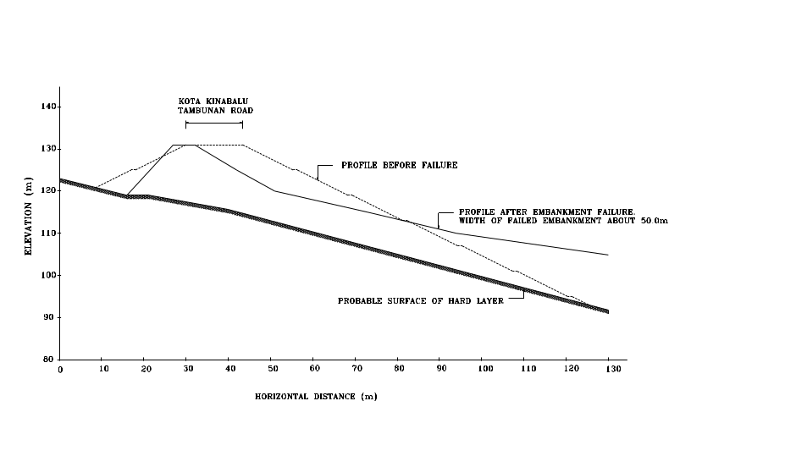
FIGURE 2 : TYPICAL SECTION OF FAILED EMBANKMENT
2.0 TOPOGRPHY

The road at this location traverses alongside cut slopes hugging to the Crocker Range formation towards a south-easterly direction to Tambunan (Fig 3). The road traverses through a rolling/mountainous terrain. At the failed area, the road traverse across a gorge connecting two hills in the south (Moyog end) and north (Tambunan end) respectively. At the location of the crossing the gorge is some 25 meters across. The existing form of crossing across the gorge is by embankment fill at approximately 12 meters in height. A CMP culvert 914mm diameter is laid at the bottom of the embankment fill to cater for the drainage. The distance of the inlet end of the culvert from the existing road centerline is approximately 12 meters and the outlet end from the existing center line is about 40 meters away.

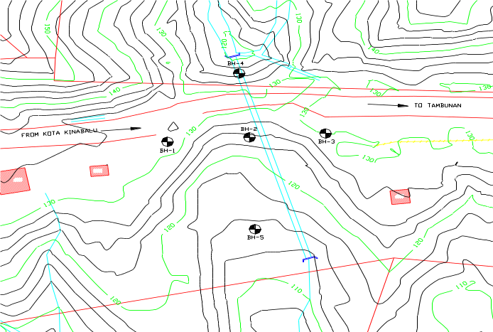

FIGURE 3 : SITE PLAN AND BORE HOLE LOCATION

The concave terrain by the two hills adjacent to the gorge contributes to the surface runoff and the formation of a stream perpendicular to the existing road alignment. The flow in the stream is permanent and erosion gullies are seen to have made their permanent mark in the terrain.

3.0 SUBSOIL INVESTIGATION

The subsoil investigation work was planned based on the survey plan. It was planned that 5 boreholes to be sank at the site. 3 numbers were located along the center line of the road and 2 numbers at the upstream and downstream of the embankment (Fig. 3). The borehole log results are shown in Fig. 4. From the relative depth of the subsoil information, a three dimensional model of the soil strata could be formulated.
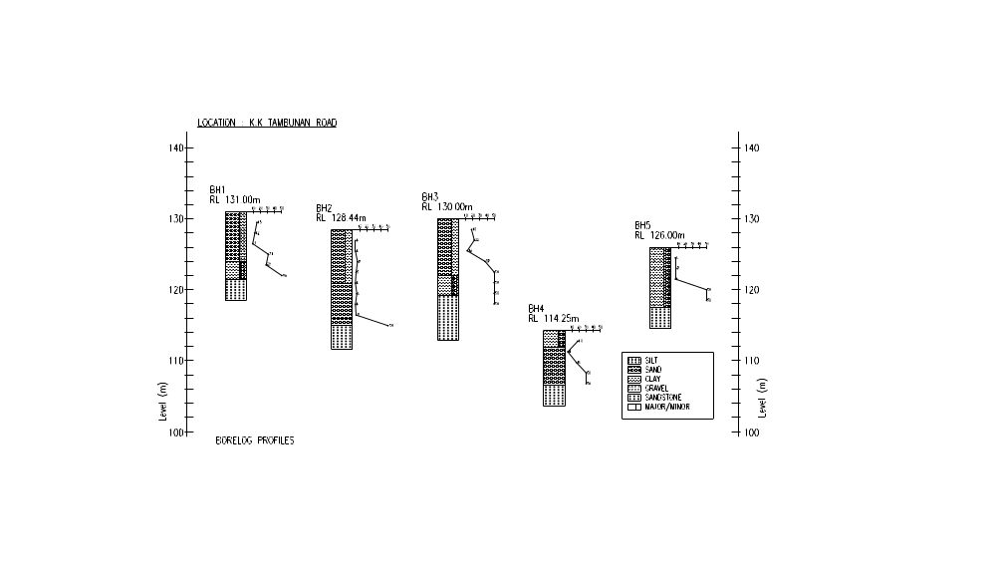

FIGURE 4 : BOREHOLE LOG
Soil samples from the potential borrow sources were also taken for laboratory testing to determine the suitability of the material for reconstruction of the embankment.

The designated tests for the subsoil investigation of the failed embankment were Standard Penetration Test, undisturbed soil sampling, water level monitoring, moisture content test, Aterberg’s Limits tests, particle size distribution analysis and triaxial test on the soil samples.

The above tests results were used for the modeling of the embankment slope and the analysis of the earth slope stability.

4.0 SUBSOIL PROFILE

The road embankment was constructed across the deep valley. The imported embankment material was simply backfilled and constructed on the existing valley floor. The borehole logs revealed that the subsoil profile of the slope (Fig 5 and Fig 6). The rock level was considered sloping generally along the center line of the valley.

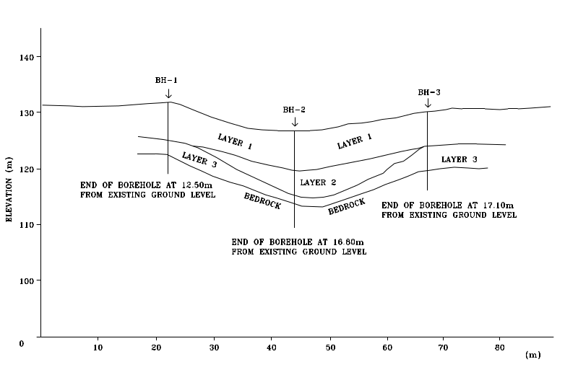

FIGURE 5 : SUBSOIL PROFILE ( BH1, BH2, BH3)

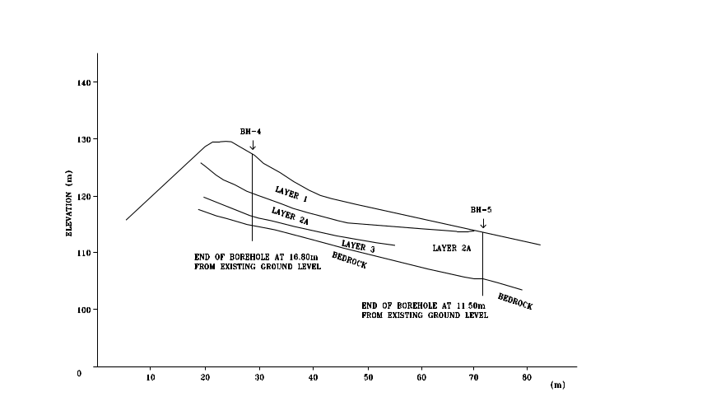

FIGURE 6 : SUBSOIL PROFILE ( BH4, BH5)

5.0 METHOD OF ANALYSIS

The slope stability analysis was carried out by using Bishop Simplified Method and Morgenstern and Price’s Method of Slices. The methods allowed us to analysie circular and non-circular sliding surfaces. The soil parameters obtained from the laboratory results were used to carry the analysis. Hundred of trials were carried out in order to obtain a minimum factor of safety for the slope.

The original embankment slope (Fig 7) was reconstructed and modeled with different ground water conditions. The result showed that the slope was marginally stable with safety factor of 1.097 under normal or dry condition. However, the slope became unstable when the ground water raised up to the height of 1.5 meters inside the embankment.

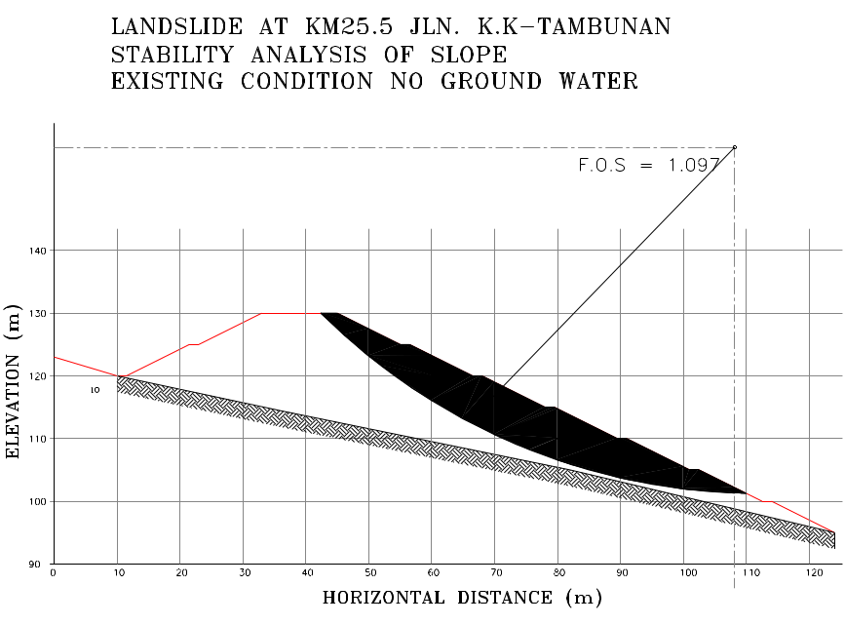
FIGURE 7 : SLOPE STABILITY

6.0 CAUSES OF EMBANKMENT FAILURE

Based on the above findings it was concluded that the failure of the embankment slope was due to the low soil strength being used for the embankment construction in the first place coupled with the built up of the ground water level in the period of heavy downpour. The clogging of the culvert by debris could contribute the built up of the ground water level inside the embankment.

7.0 REMEDIAL WORKS

Four proposals were put forward for the remedial work. Various factors were considered in the selection of the best solution. The factors are:

- Technically feasible,
- Easy and fast to construct,
- Safe solution,
- Need minimum supervision,
- Environment friendly,
- Cost effective.

7.1 Option 1 : Re-alignment of the Road

The road was planned to be realigned to the hill side to avoid disturbance to the site. The work would involve the construction of the box culvert, cutting into the steep hill side slope, importing suitable embankment material and needed extensive sub-surface drainage structure. The main disadvantage of this option is that it would reduce the traffic speed and sight distances.

7.2 Option 2 : Reconstruction of Embankment

The work involved the removal of the existing failed embankment material and imported suitable backfill material for the reconstruction work.

The problem of this option is that no suitable borrow material could be found in this area. The proposed borrow source material with the low material strength could not achieve the required factor of safety. In addition to above, the climatic condition in this area does not warrant this construction method as the weather in this area is unpredictable. The weather is always wet most of the time that make the compaction and supervision work difficult. Moreover, the backfill material had to be imported from the borrow source where the existing jungle had to be cleared for the material which is not environment friendly.

7.3 Option 3 : Construction of a Bridge Structure

It was proposed that a 60 meters long 3 span steel girder concrete composite bridge to be built across the valley. The work would involve the removal of the existing failed embankment material and construction of the concrete piers, abutment and bridge superstructure (Fig 8)

The advantage of this option is that it could restore the valley to its original condition where the stream water could flow to its natural stage as before. In addition to above, the construction work is fast and material quality could be easily controlled.

The disadvantage is that the steel material has to be imported from outside the country with high construction cost.

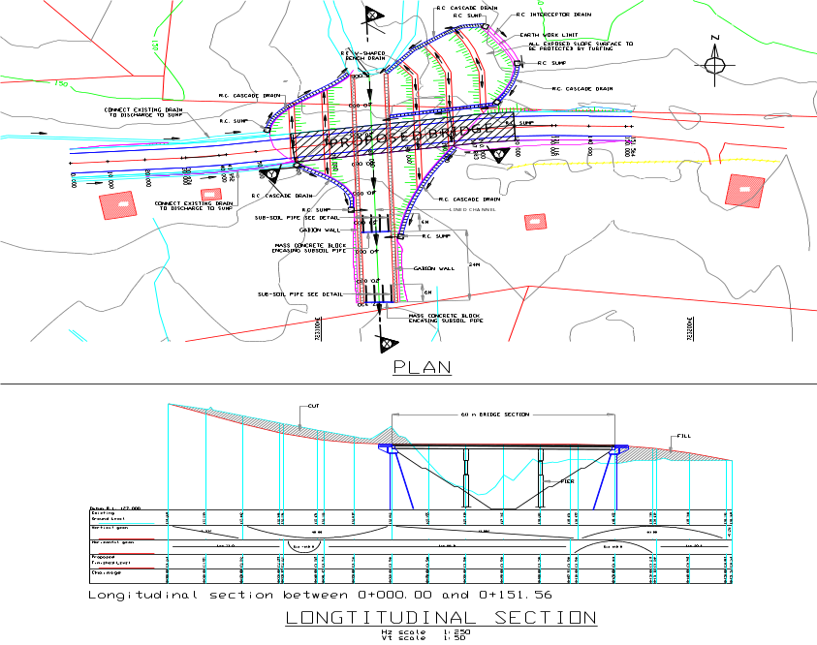
FIGURE 8 : BRIDGE STRUCTURE PLAN AND SECTION
7.4 Option 4: Reinforced Soil Wall

In this option, two reinforced soil walls were proposed to contain the road embankment with a box culvert situated in the middle to discharge water from the stream (Fig 9 and Fig 10). The slope on top of the reinforced soil wall is trimmed to a gentle slope of 1V:1.80H and close turfed to prevent surface erosion. Cast-in-situ V-shaped berm drains are installed to provide drainage for surface runoff. The work involved the removal of the existing failed embankment material and the construction of the wall.

This option was considered and selected because of the lowest cost of construction. This was contributed to the inherent advantage that quarry dust/sand was available with low cost from the nearby quarry which was only located 2 Km away from the project site. In addition to the above, the work can be carried out with relatively fast speed and all the construction material are easy to handle. The compaction can be achieved with minimum supervision even under the prevailing wet weather condition at the site because of the suitable granular material.

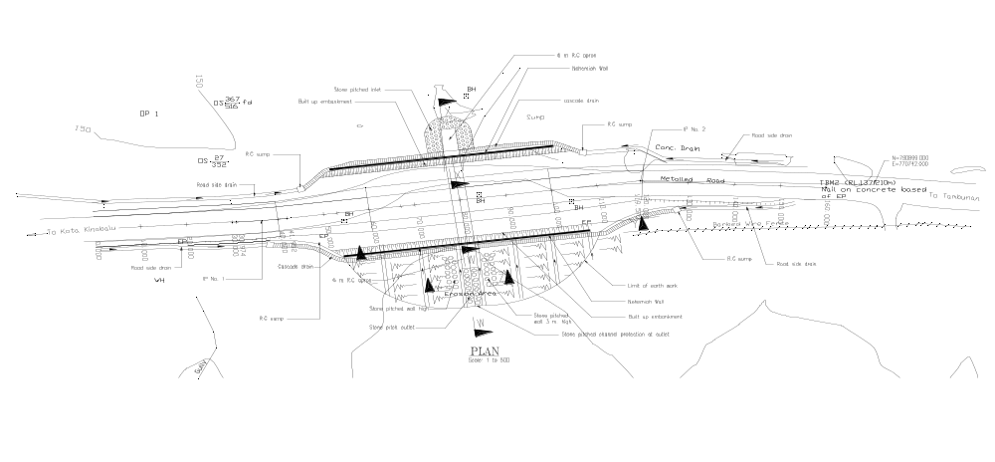
FIGURE 9 : LAYOUT OF NEHEMIAH WALL ALIGNMENT

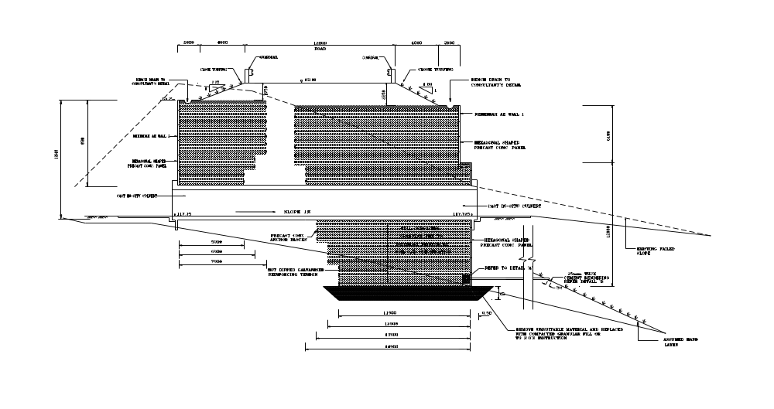

FIGURE 10 : TYPICAL DESIGN CROSS SECTION OF NEHEMIAH WALL

8.0 DESIGN

The Nehemiah wall is a type of reinforced soil wall whereby it consists of precast concrete panels as facing and reinforcing bars and anchor blocks as reinforcement. The mode of stress transfer from the backfill to the reinforcement is by passive resistance in addition to friction. The advantage of such a system is cost effectiveness through design and use of locally available material like steel bars and concrete. The design is based on the BS 8006:1995 code of practice for Strengthened/reinforced soils and other fills. The alignment of Nehemiah Wall is shown in Fig. 9 and the typical design cross section is shown in Fig. 10. The design of the Nehemiah wall involves the external stability analysis and the internal stability analysis.

8.1 EXTERNAL STABILITY

For the external stability analysis, the Nehemiah wall is analyzed as a gravity block. The factors of safety against sliding, overturning and bearing were checked and designed to ensure that they are adequate. (see Fig. 11).

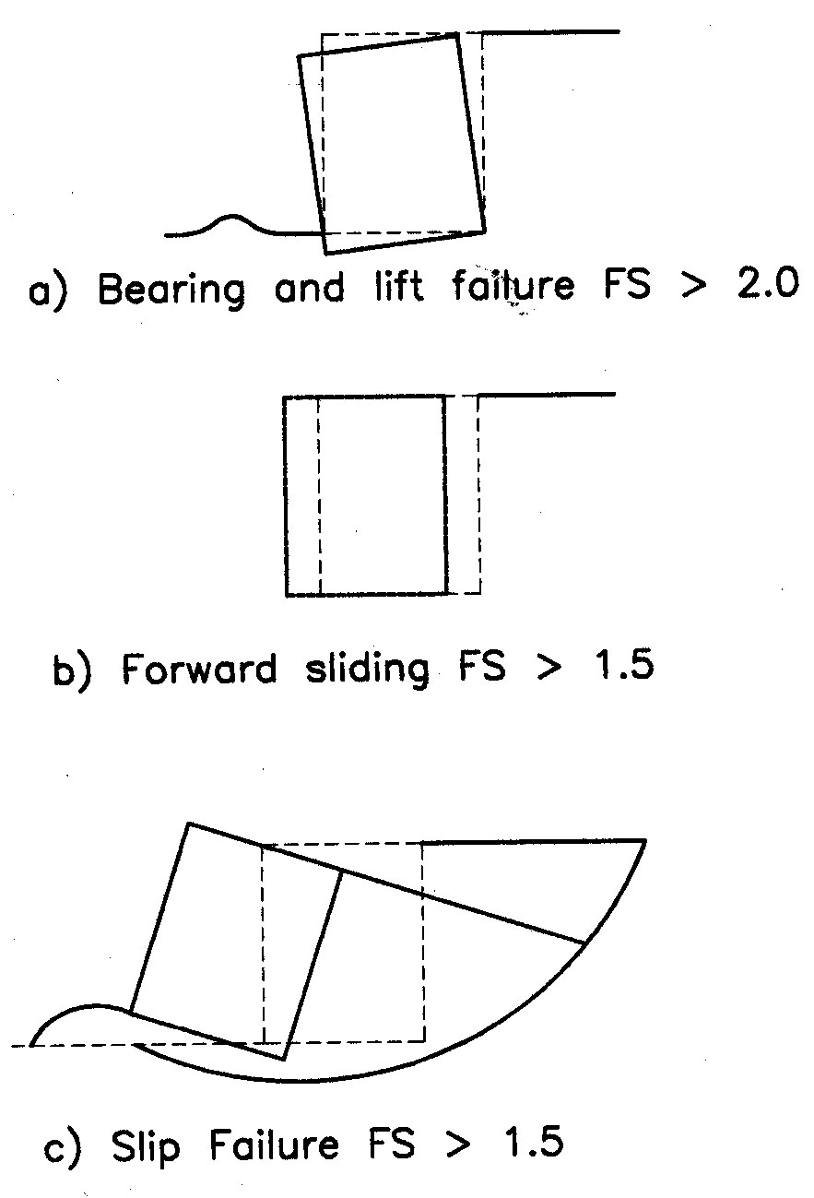

FIGURE 11 : EXTERNAL STABILITY CHECKLIST

8.2 Internal Stability

The internal stability analysis involved checks to ensure that the factors of safety against
tensile and pull-out failure of the reinforcing tendons are adequate.

8.2.1 Tensile Failure

T_{i} = K S_{v} σ_{v}

where

T_{i} is tension developed in the reinforcing tendon at i th level
K is the coefficient of earth pressure within the reinforced block
S_{v} is the vertical spacing of the tendons
σ_{v} is the vertical stress acting on the i th level of the tendons according to the Meyerhof pressure distribution

In the design, it is important that the number and size of reinforcing tendons are adequately provided so that the tension developed in the tendons is always less than the allowable tensile strength of the tendons.

8.2.2. Pull Out Failure

The ultimate pull out resistance of the reinforcing tendons is the sum of the shaft frictional resistance and the anchor capacity of the anchor block. The shaft resistance is determined by the friction developed between the backfill and the effective length of the tendon which is shown in Fig. 12.

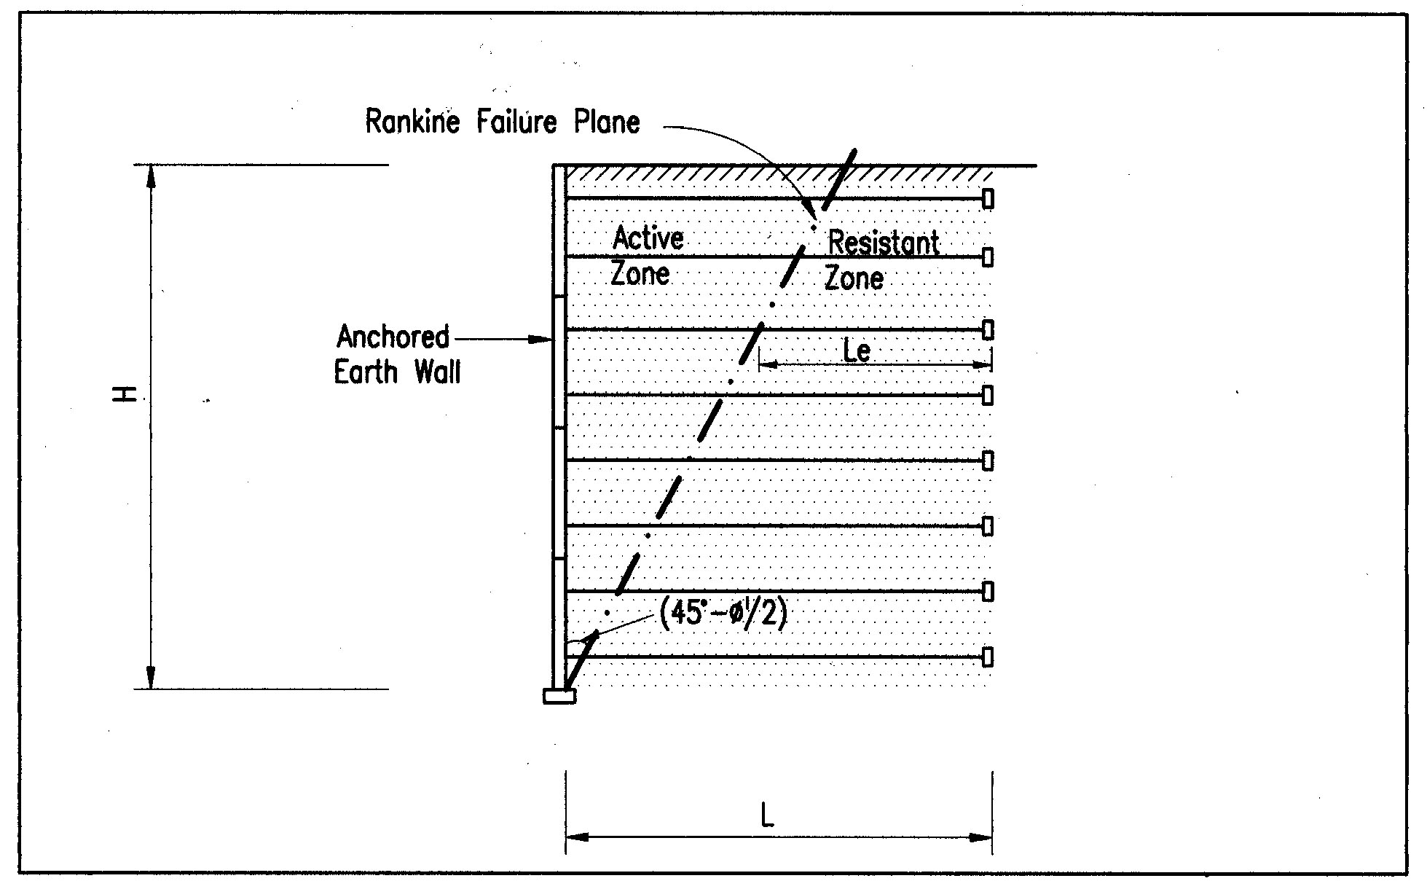FIGURE 12 : EFFECTIVE LENGTH OF REINFORCING TENDONS - L_{e}
The shaft resistance is computed as follows:

F_{s} = µ tan Ø ¶ d L_{e} σ_{v}

where

F_{s} is the shaft resistance
µ is the coefficient of friction
Ø is the internal angle of friction of backfill
d is the diameter of the tendon
L_{e} is the effective shaft length
(Fig. 10)

The anchor capacity is computed as follows:

P_{a} = 4 K_{p} h w σ_{v}

where

P_{a} is the passive resistance of the backfill in front of the anchor block
σ_{v} is the vertical stress at the i th level of tendon
K_{p} is the coefficient of passive earth pressure
h is the height of the anchor block
w is the width of the anchor block

Hence, the total pull out resistance

P = P_{a} + F_{s}

9.0 CONSTRUCTION

The reconstruction of the road embankment at Km 25.5, Kota Kinabalu – Tambunan road posed many challenges and constraints as it is located in a very deep valley. The difficult task was further compounded by the heavy rainfall intensity within that area. Conventional earth embankment design would entail extensive earthworks including cut and fill. However, under existing site conditions, this
design is not ideal due to the incessant rainfall that may undermine the long term stability of the embankment slope. Massive earthworks should also be avoided to prevent potentially irreversible degradation to the surrounding environment which comprise pristine jungles. The Nehemiah wall proved to be an ideal long term solution under such circumstances due to its cost effectiveness, speed of construction and durability. The construction sequence shall start with site preparation before wall construction can commence.

9.1 Site Preparation

9.1.1 Excavation

Excavation for the base and width of the wall is carried out as per the alignment setting out by the surveyor. The depth and width of excavation shall comply to the levels as shown in the construction drawing.

9.1.2 Base Preparation

The foundation base shall be leveled and well compacted for a width equal to the length of the reinforcing bars. Any soft spot shall be removed and replaced with well compacted granular material..

9.1.3 Concrete Levelling Pad

The mass concrete leveling pad shall be constructed with Grade 20 concrete without any reinforcement. The leveling pad shall be cast along the wall alignment at the required levels, 24 hours prior to actual wall construction.
Upon completion of site preparation works, the physical erection and installation of the wall can proceed.

9.2 Wall Erection

9.2.1 Installation

The process of wall erection is illustrated in the sketch shown in Fig. 13. The facing panels are hoisted with the aid of a lifting device. They are placed in successive courses. The spacing, level and alignment of each panel are individually checked immediately after its placement and again at the completion of each course. The initial row of panels are braced externally. Each row of the panels are followed immediately by the placement of fill and the connection of the reinforcing bars before the next successive horizontal row of panels is being erected.

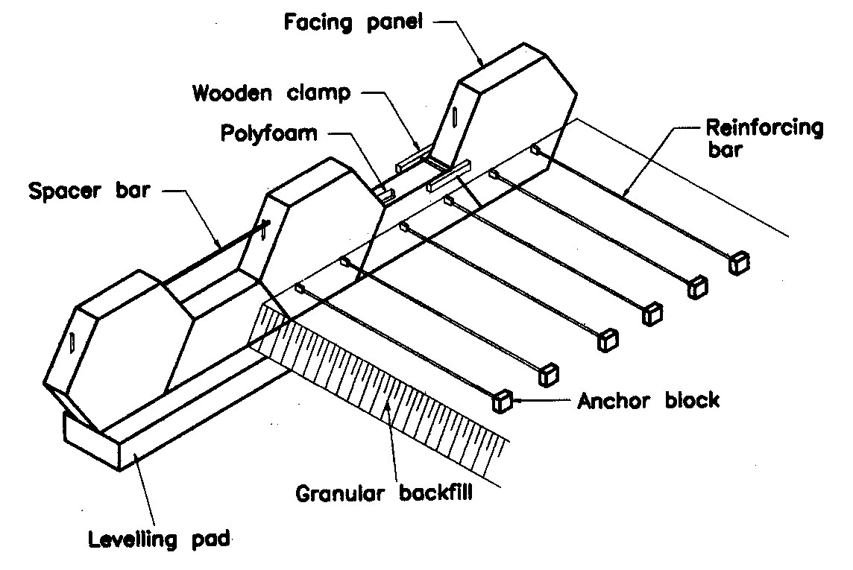

FIGURE 13 : CONSTRUCTION OF NEHEMIAH WAL

The subsequent rows of panels shall be held in place by temporary clamps securing the present rows of panels to the previously erected rows which is already held firmly in place by the reinforcing bars buried in the backfill.

Except for the bottom course of panels, all others panels shall be tilted towards the fill material during placement to compensate for the outward movement expected during or subsequent to compaction of the fill material. The degree of inclination shall be adjusted where necessary as placement and compaction of fill material proceeds to ensure that the verticality of the wall complies with the requirements.

9.2.2 Joint Materials and Cushion Pads

Joint materials are placed in all the joints between the panels. They shall be placed on the cleaned top edges of each facing panels just prior to the placing of the mating facing panel. No joint material is required between the leveling pad and the bottom course of the facing panels.

Cushion pads shall be placed at the slots on the top edge of each panel before the installation of the subsequent row of panels.

9.2.3 Alignment and Verticality

The alignment and verticality are constantly checked with a plumb bob and adjusted with the aid of temporary timber wedges inserted into the joints between the panels. The timber wedges shall be removed as soon as their functions are fulfilled.

9.3 Backfilling

9.3.1 Placement of Fill

Backfilling operation is carried out immediately following the completion of the installation of each row of panels. The fill material shall be deposited, spread, levelled and compacted in layers of thickness of not exceeding 375 mm so that each reinforcing bar can be fixed at the required level on top of the compacted fill material without any voids forming directly underneath the reinforcing bar.

The direction of travel of the construction vehicle for the placement, spreading and compaction of the fill is parallel to the alignment of the wall at all times. Sharp turn of vehicle or movement perpendicular to the wall causing centrifugal forces exerting toward the rear face of the panels is prohibited.

No heavy vehicle weighing more than 1000 kg shall be allowed within the 1.5 m zone from the rear face of the panel.

The travelling of construction vehicles especially those with crawler track wheels directly onto the reinforcing element is also not permitted.

9.3.2 Compaction

The fill material is compacted to 95% of the maximum dry density as determined in accordance with BS 1377:1975.

During the backfilling operation and compaction, trucks and heavy construction vehicles shall be kept back at least 1.5 m away from the back face of the facing panel. The 1.5 m zone shall be compacted with a 1.0 ton vibratory plate compactor.

  - CONSTRUCTION CHALLENGES

The steep terrain at the site proved to be a major obstacle during the construction works. Movements of heavy machineries such as excavators, cranes, lorries etc were greatly impaired due to accessibility constraints. The transportation of construction materials to the bottom of the valley was a formidable task due to the multiple handling and shifting operations. Likewise, the granular backfill material could not be deposited directly on the backfilling area and it had to be discharged on the cut slope and then subsequently shifted bucket by bucket by the excavator. Space congestion also limited the deployment of more machineries thereby slowing down progress significantly.

Another major challenge confronted during the construction was the management of surface runoff. As the site is situated in a deep valley and exposed to high rainfall intensity, it is of paramount importance that surface runoff diversion and management is tackled. Surface runoff from the temporary access road was blocked and diverted from overflowing into the working area by a series of earthdrains and earth bunds. In addition, a water retention pond that also function as a silt trap was constructed at the bottom of the valley to capture runoff that flowed into the working area. The management of surface runoff continued to be crucial until the box culvert was completed.

10.0 CONCLUSION

Two Nehemiah walls containing the road embankment with a box culvert situated in the middle were successfully constructed in February 2001 despite the challenges of a very deep valley and heavy rainfall intensity within that area. It provides a cost effective and quick solution to embankment failure problem which is common in Malaysia with her intensive rainfall. Todate, the completed Nehemiah embankment walls are performing satisfactorily. (see Figure 14 & 15)

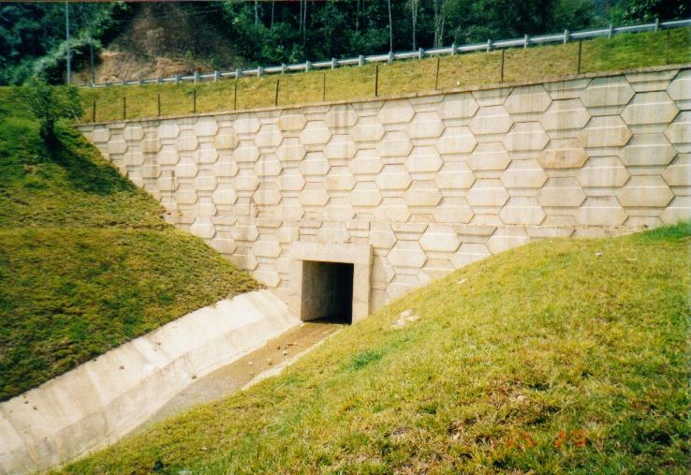
Figure 14 : Picture of Completed Nehemiah Wall at Outlet
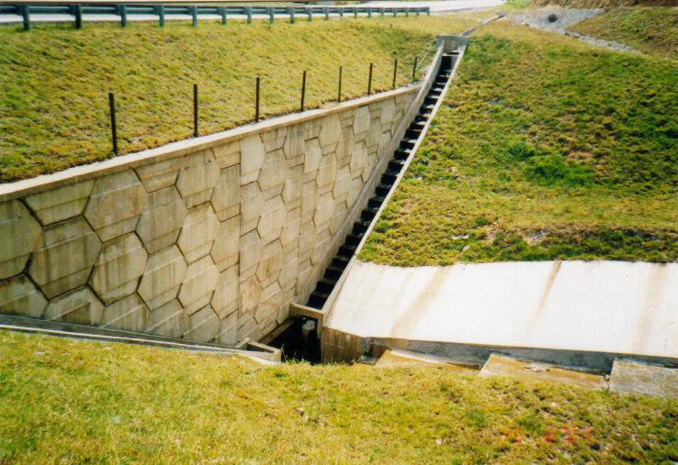
Figure 15 : Picture of Completed Nehemiah Wall at Inlet

REFERENCE

BS8006:1995 Code of Practice for Strengthened/Reinforced Soils and Other Fills, Bristish Standards Institution.

G.I.GRABB and J.H. ATKINSON. Determination of soil strength parameters for analysis of highway slope failures. International Conference on Slope Stability Engineering – Development and Applications. Thomas Telford, London 1991.

QUIDO ZARUBA and VOJECH MENCL. Landslides and Their Control.

Geotechnical Manual for Slope, 2nd EDITION (1984) geo Hong Kong Publication
Guide to Retaining Wall Design, 2nd Edition (1993). Geoguide 1, GEO Hong Kong Publication.

POULOS, H.G. and DAVIS, E.H (1980) “Pile Foundation Analysis and Embankment”. John Wiley and Sons, New York.

BS5400 : 1984. Steel, Concrete and Composite Bridge, British Standards Institution.

.

